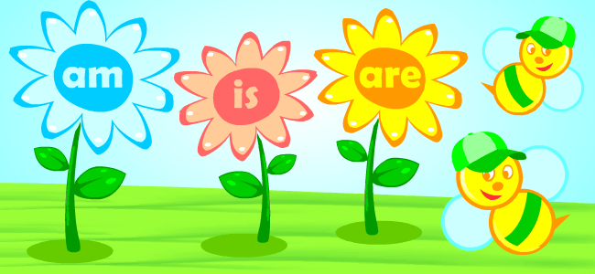VERB TO BE

- Circle the correct option.
- They am/are/is at school.
- I am/are/is at home.
- Riga am/are/is in Latvia.
- Jane am/are/is a teacher.
- We am/are/is best friends.
- He am/are/is from Italy.
- Complete with AM, ARE or IS.
- I …………………………….from Latvia.
- It …………………………….a big school.
- She …………………………..my friend.
- We ………………………….in London.
- He ……………………..a student.
- You ……………………………a pop star.
- They …………………………….tall.
- Tom ………………….a baby.
- Sue and I ………………………friends.
- They …………………………my parents.
- Write the negative of the following sentences.
- He is my best friend. ……………………………………………………………….
- They are very kind. …………………………………………………………………….
- We are students. ………………………………………………………………………..
- I am 12 years old. ………………………………………………………………………
- He is a policeman. ……………………………………………………………………….
- You are at school. ……………………………………………………………………
- It is a big cat. ……………………………………………………………………………..
- Peter and I are happy. ………………………………………………………………
- Jane and Susan are doctors. ……………………………………………………
- They are at school. …………………………………………………………………….
- Complete with AM, ARE or IS to form interrogative sentences.
- ……………………….it post office?
- ………………………they students?
- ………………………I funny?
- ………………………she at school?
- ……………………..you a doctor?
- Write the interrogative of these sentences.
- They are very kind. ……………………………………………………………………..
- She is tall. ……………………………………………………………………………………..
- He is a teacher. ………………………………………………………………………………
- We are happy. ……………………………………………………………………………….
- I am hungry. …………………………………………………………………………………..
- Choose the correct answer.
1) The bag (be) ________ blue.
A. am B. are C. is
2) It (be) ________ easy.
A. am B. are C. is
3) They (be) ________ young.
A. am B. are C. is
4) Thomas (be) ________ nice.
A. am B. are C. is
5) I (be) __________ a doctor.
A. am B. are C. is


