WORKSHEET
1.- COMPLETE THE CROSSWORD.
 | 1. 10 + 10 =…………………………………  2. 8 + 2 =……………………………………  3. 17 + 2 =…………………………………  4. 4 + 7 = …………………………………  5. 9 + 9 =…………………………………..  6. 5 + 9 =…………………………………..  7. 12 + 3 =…………………………………  8. 3 + 13 =…………………………………  9. 14 + 3 =…………………………………
   |  |  |  |  |  |  |  | 1
   |  |  | 6
   |  |  |  |  | 7 | 2
   |  |  |  |  |  |  |  |  |  | 4
   |  |  | 3
   |  |  |  |  |  | 8
   |  |  |  | 5
   |  |  |  | 9

2.- HOW MANY?
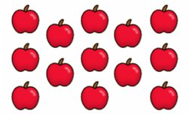  thirteen |   ..................................................... |           

