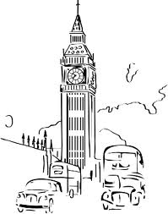**Quiz:**

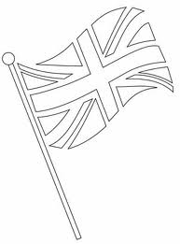 **How much do you know about Great Britain?**

**1. What is the official name of Great Britain?**

1. The United Kingdom
2. The United States of Great Britain and Northern Ireland
3. The United Kingdom of great Britain and Northern Ireland

**2. Which is the Great Britain capital?**

1. New York City
2. Bonn
3. London

**3. What’s the name of the most famous clock in Britain?**

1. Big Albert
2. Big Wren
3. 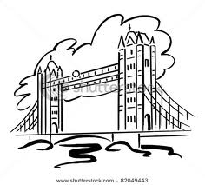Big Ben

**4. What London street is famous for shops?**

1. Lombard Street
2. Downing Street
3. Oxford Street

**5. Who is the head of the state in Britain?**

1. the Queen
2. the Speaker
3. the Prime Minister
4. **What is the name of the flag of Great Britain?**
5. the Jolly Roger
6. the United States
7. the Union Jack
8. **What is the emblem of England?**
9. a thistle
10. a shamrock
11. a rose

**8**. **What is the name of the London's residence of Queen Elizabeth II?**

1. Windsor Palace
2. Kensington Palace
3. Buckingham Palace

**9**. **Whose monument stands in the centre of Trafalgar Square?**

1. Admiral Nelson
2. General Washington
3. Former prime minister Winston Churchill

**10. What river is London situated on?**

1. The Nile
2. The Thames
3. The Mississippi

**11. What is Humpty Dumpty?**

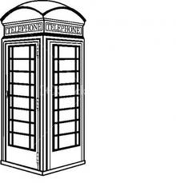 **17. What is the name of London buses?**

1. a toy a. two-storey-bus
2. an egg 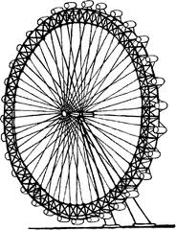 b. double bus
3. a bird c. double-decker

**12**. **William Shakespeare was a famous English...** **18. English children start going to school at the age of:**

1. artist a. 7
2. doctor b. 6
3. writer c. 5

**13**. **What is the nickname of London Underground?** **19**. **Where does the British Premier live and work?**

1. Subway a. **at 10 Downing Street**
2. The Tube b. **in the House of Parliament**
3. Underground c. **in Buckingham Palace**

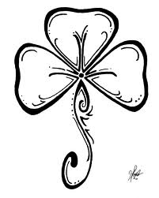**14**. **Translate into English: Век живи - век учись. 20. The ravens are a famous sight of …**

1. Better late than never. a. **London Zoo**
2. First think, than speak. b. **Covent Garden**
3. Live and learn. c**. the Tower of London**

**15**. **For Christmas dinner the English usually have: 21. The traditional English drink is..**

1. 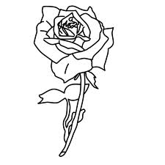Turkey a. coffee
2. Chicken b. tea
3. roast beef c. whiskey

**16. How many parts are there in Great Britain? GOOD LUCK!**

1. 4
2. 3
3. 1