Проверочная работа по русскому языку в 3 классе. Февраль.

Фамилия имя __________________________________________________

**1.Спиши текст, вставляя пропущенные буквы. (8 п.)**

В наших лесах ж..вёт ро(б,п)кий зв..рёк. Летом на нём серенькая лё..кая шу..ка. К зиме он меняет её на пуш..стую белен..кую. Она сп..сает зв..рька от м..роза. Жил..я у бедняги нет. Хор..шо служат ему дли(н,нн)ые ноги. Больш..ми пры..ками уб..гает трусишка от вр..гов.

­­­­­­­­­­­­­­­­­­­­­­­­­­­­­­­­­­­­­­­­­­­­­­­­­­­­­­­­­­­­­­­­­­­­­­­­­­­­­­­­­­­­­­­­­­­­­­­­­­­­­­­­­­­­­­­­­­­­­­­­________________________________________________________________________

­­­­­­­­­­­­­­­­­­­­­­­­­­­­­­­­­­­­­­­­­­­­­­­­­­­­­­­­­­­­­­­­­­­­­­­­­­­­­­­­­­­­­­­­­­­­­­­­­­­­­­­­­­­­­­­­­­­­­­­­________________________________________________________________________

­­­­­­­­­­­­­­­­­­­­­­­­­­­­­­­­­­­­­­­­­­­­­­­­­­­­­­­­­­­­­­­­­­­­­­­­­­­­­­­­­­­­­­­­­­­­­­­­­­­­­­­­­­­­­­­­­­­­­­­­________________________________________________________________________

­­­­­­­­­­­­­­­­­­­­­­­­­­­­­­­­­­­­­­­­­­­­­­­­­­­­­­­­­­­­­­­­­­­­­­­­­­­­­­­­­­­­­­­­­­­­­­­­­­­­­­­­­­­­­­­­­­­­­­­­________________________________________________________________________

­­­­­­­­­­­­­­­­­­­­­­­­­­­­­­­­­­­­­­­­­­­­­­­­­­­­­­­­­­­­­­­­­­­­­­­­­­­­­­­­­­­­­­­­­­­­­­­­­­­­­­­­­­­­­­­­­­­­­­­­________________________________________________________________________

­­­­­­­­­­­­­­­­­­­­­­­­­­­­­­­­­­­­­­­­­­­­­­­­­­­­­­­­­­­­­­­­­­­­­­­­­­­­­­­­­­­­­­­­­­­­­­­­­­­­­­­­­­­­­­­­­­­­­­­­________________________________________________________________________

­­­­­­­­­­­­­­­­­­­­­­­­­­­­­­­­­­­­­­­­­­­­­­­­­­­­­­­­­­­­­­­­­­­­­­­­­­­­­­­­­­­­­­­­­­­­­­­­­­­­­­­­­­­­­­­­­­­­­­­­________________________________________________________________________

­­­­­­­­­­­­­­­­­­­­­­­­­­­­­­­­­­­­­­­­­­­­­­­­­­­­­­­­­­­­­­­­­­­­­­­­­­­­­­­­­­­­­­­­­­­­­­­­­­­­­­­­­­­­­­­­­­­­­­­­________________________________________________________________________

­­­­­­­­­­­­­­­­­­­­­­­­­­­­­­­­­­­­­­­­­­­­­­­­­­­­­­­­­­­­­­­­­­­­­­­­­­­­­­­­­­­­­­­­­­­­­­­­­­­­­­­­­­­­­­­­­­­­­­­­________________________________________________________________________

**2.Составь и запиши словосочетания, образовав от существительных, данных в скобках, прилагательные. (3 п.)**

Образец: (честь) поступок - честный поступок

(радость) улыбка - ____________________________________

(ненастье) погода - ____________________________________

(место) житель - _______________________________________

**3.Вставь пропущенные буквы. Запиши проверочные слова. (3 п.)**

Звёз…ный _____________________________

Грус…ный _____________________________

Счас…ливый ___________________________

**4.Запиши предложения, раскрывая скобки. Выдели приставки, подчеркни предлоги. (6 п.)**

Колобок (с)катился (с)окошка, (по)катился (по)дорожке, (до)катился (до)леса.

­­­­­­­­­­­­­­­­­­­­­­­­­­­­­­­­­­­­­­­­­­­­­­­­­­­­­­­­­­­­­­­­­­­­­­­­­­­­­­­­­­­­­­­­­­­­­­­­­­­­­­­­­­­­­­­­­­­­­­­­________________________________________________________________________

­­­­­­­­­­­­­­­­­­­­­­­­­­­­­­­­­­­­­­­­­­­­­­­­­­­­­­­­­­­­­­­­­­­­­­­­­­­­­­­­­­­­­­­­­­­­­­­­­­­­­­­­­­­­­­­­­­­­­­­­________________________________________________________________________

­­­­­­­­­­­­­­­­­­­­­­­­­­­­­­­­­­­­­­­­­­­­­­­­­­­­­­­­­­­­­­­­­­­­­­­­­­­­­­­­­­­­­­­­­­­­­­­­­­­­­­­­­­­­­­­­­­­­­­­­________________________________________________________________________

**5.Составь с данными словами небольшой рассказ. Озаглавь его. (10п.)**

Зимний денёк, отличная погода, пушистые снежинки, липкий снег, весёлый снеговик, кататься на санках.

­­­­­­­­­­­­­­­­­­­­­­­­­­­­­­­­­­­­­­­­­­­­­­­­­­­­­­­­­­­­­­­­­­­­­­­­­­­­­­­­­­­­­­­­­­­­­­­­­­­­­­­­­­­­­­­­­­­­­­­­________________________________________________________________________

­­­­­­­­­­­­­­­­­­­­­­­­­­­­­­­­­­­­­­­­­­­­­­­­­­­­­­­­­­­­­­­­­­­­­­­­­­­­­­­­­­­­­­­­­­­­­­­­­­­­­­­­­­­­­­­­­­­­­­­­________________________________________________________________________

­­­­­­­­­­­­­­­­­­­­­­­­­­­­­­­­­­­­­­­­­­­­­­­­­­­­­­­­­­­­­­­­­­­­­­­­­­­­­­­­­­­­­­­­­­­­­­­­­­­­­­­­­­­­­­­­­­­­­­­­________________________________________________________________________

­­­­­­­­­­­­­­­­­­­­­­­­­­­­­­­­­­­­­­­­­­­­­­­­­­­­­­­­­­­­­­­­­­­­­­­­­­­­­­­­­­­­­­­­­­­­­­­­­­­­­­­­­­­­­­­­­­­­­­­­________________________________________________________________________

­­­­­­­­­­­­­­­­­­­­­­­­­­­­­­­­­­­­­­­­­­­­­­­­­­­­­­­­­­­­­­­­­­­­­­­­­­­­­­­­­­­­­­­­­­­­­­­­­­­­­­­­­­­­­­­­­­­­­­­­________________________________________________________________________

­­­­­­­­­­­­­­­­­­­­­­­­­­­­­­­­­­­­­­­­­­­­­­­­­­­­­­­­­­­­­­­­­­­­­­­­­­­­­­­­­­­­­­­­­­­­­­­­­­­­­­­­­­­­­­­­­­­­­­­­________________________________________________________________________

­­­­­­­­­­­­­­­­­­­­­­­­­­­­­­­­­­­­­­­­­­­­­­­­­­­­­­­­­­­­­­­­­­­­­­­­­­­­­­­­­­­­­­­­­­­­­­­­­­­­­­­­­­­­­­­­­­­­­­­­________________________________________________________________________

­­­­­­­­­­­­­­­­­­­­­­­­­­­­­­­­­­­­­­­­­­­­­­­­­­­­­­­­­­­­­­­­­­­­­­­­­­­­­­­­­­­­­­­­­­­­­­­­­­­­­­­­­­­­­­­­­­­­­­­­________________________________________________________________________

­­­­­­­­­­­­­­­­­­­­­­­­­­­­­­­­­­­­­­­­­­­­­­­­­­­­­­­­­­­­­­­­­­­­­­­­­­­­­­­­­­­­­­­­­­­­­­­­­­­­­­­­­­­­­­­­­­­­­­­­________________________________________________________________________

­­­­­­­­­­­­­­­­­­­­­­­­­­­­­­­­­­­­­­­­­­­­­­­­­­­­­­­­­­­­­­­­­­­­­­­­­­­­­­­­­­­­­­­­­­­­­­­­­­­­­­­­­­­­­­­­­­­­­­­­________________________________________________________________________

­­­­­­­­­­­­­­­­­­­­­­­­­­­­­­­­­­­­­­­­­­­­­­­­­­­­­­­­­­­­­­­­­­­­­­­­­­­­­­­­­­­­­­­­­­­­­­­­­­­­­­­­­­­­­­­­­­­­­­­­________________________________________________________________________

­­­­­­­­­­­­­­­­­­­­­­­­­­­­­­­­­­­­­­­­­­­­­­­­­­­­­­­­­­­­­­­­­­­­­­­­­­­­­­­­­­­­­­­­­­­­­­­­­­­­­­­­­­­­­­­­­­­­­­­­________________________________________________________________________

­­­­­­­­­­­­­­­­­­­­­­­­­­­­­­­­­­­­­­­­­­­­­­­­­­­­­­­­­­­­­­­­­­­­­­­­­­­­­­­­­­­­­­­­­­­­­­­­­­­­­­­­­­­­­­­­­­­­­­­­________________________________________________________________________

­­­­­­­­­­­­­­­­­­­­­­­­­­­­­­­­­­­­­­­­­­­­­­­­­­­­­­­­­­­­­­­­­­­­­­­­­­­­­­­­­­­­­­­­­­­­­­­­­­­­­­­­­­­­­­­­­­­­­­­­________________________________________________________________________

­­­­­­­­­­­­­­­­­­­­­­­­­­­­­­­­­­­­­­­­­­­­­­­­­­­­­­­­­­­­­­­­­­­­­­­­­­­­­­­­­­­­­­­­­­­­­­­­­­­­­­­­­­­­­­­­­­­­­­­­________________________________________________________________________

­­­­­­­­­­­­­­­­­­­­­­­­­­­­­­­­­­­­­­­­­­­­­­­­­­­­­­­­­­­­­­­­­­­­­­­­­­­­­­­­­­­­­­­­­­­­­­­­­­­­­­­­­­­­­­­­­­­­­­­­________________________________________________________________________

­­­­­­­­­­­­­­­­­­­­­­­­­­­­­­­­­­­­­­­­­­­­­­­­­­­­­­­­­­­­­­­­­­­­­­­­­­­­­­­­­­­­­­­­­­­­­­­­­­­­­­­­­­­­­­­­­­­­­­­­________________________________________________________________________

­­­­­­­­­­­­­­­­­­­­­­­­­­­­­­­­­­­­­­­­­­­­­­­­­­­­­­­­­­­­­­­­­­­­­­­­­­­­­­­­­­­­­­­­­­­­­­­­­­­­­­­­­­­­­­­­­­­­­­­­________________________________________________________________________

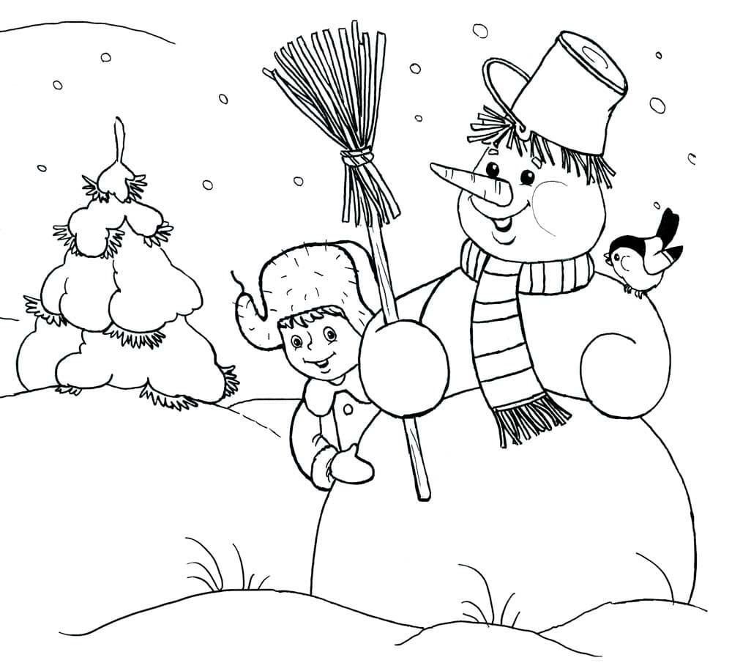­­­­­­­­­­­­­­­­­­­­­­­­­­­­­­­­­­­­­­­­­­­­­­­­­­­­­­­­­­­­­­­­­­­­­­­­­­­­­­­­­­­­­­­­­­­­­­­­­­­­­­­­­­­­­­­­­­­­­­­­

Всего 30 п.