Tēma : Veselīgs dzīves veids

Pārbaudes darbs ir paredzēts 5 – 6 klašu skolēniem. Mērķis ir pārbaudīt skolēnu rakstīšanas un lasīšanas prasmi un leksikas zināšanu.

Uzdevumus var izmantot arī kā papildmateriālu angļu valodas stundās.

**Healthy lifestyle**

**Task 1. These people are ill. What’s the matter with them? Write sentences.**

**Mark ___ /8**

A. B. C. D.

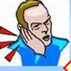  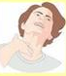 

E. F. G. H.

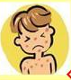 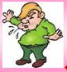  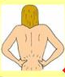

1. Mr Ford ________________________________________________________________

2. Uncle Ben ______________________________________________________________

3. Liam ___________________________________________________________________

4. Greg___________________________________________________________________

5. Tom ___________________________________________________________________

6. Luke ___________________________________________________________________

7. Alex ____________________________________________________________________

8. Jake ____________________________________________________________________

**Task 2. They treat people. Write their jobs. Mark _____ /4**

  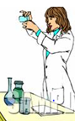 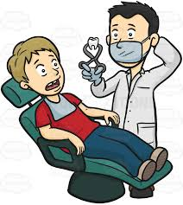

_____________ ________________ _______________ ________________

**Task 3. Choose the best word to fill the gap. Circle A, B or C. Mark ____ / 10**

1. Luis has got _________________________ flu.

2. You can get some cough medicine at the _____________________________.

3. Hepatitis is ____________________________ affecting the liver.

4. Some doctors tell us that we _________________ to eat a lot of carbohydrates.

These give us a lot of energy.

5. Little Johnny has got a rash. It’s ____________________________________.

6. Aunt Annie ___________________________ a painkiller from her headache.

7. You _______________________________ drink two litres of water every day.

8. Lucy doesn’t eat fast food, because it makes her _________________ weight.

9. Doctors say that protein is essential for building _______________________.

10. Vitamin C can help __________________ us against colds and flu.

|  |  |  |  |  |  |  |
| --- | --- | --- | --- | --- | --- | --- |
| 1. | A. | - | B. | a | C. | the |
| 2. | A. | surgeon’s | B. | chemist’s | C. | optician’s |
| 3. | A. | an ache | B. | a pain | C. | a disease |
| 4. | A. | have | B. | must | C. | need |
| 5. | A. | itchy | B. | swollen | C. | bleeding |
| 6. | A. | dropped | B. | ate | C. | took |
| 7. | A. | should | B. | might | C. | have to |
| 8. | A. | put on | B. | lose | C. | store |
| 9. | A. | elbows | B. | ankles | C. | muscles |
| 10. | A. | provide | B. | protect | C. | contain |

**Task 4. Read Helen’s blog and match the missing phrases a-f to the correct place**

**1-6 in the text. Mark ____ /6**

a I had a cup of tea d because I was late for school

b I cooked some bacon and eggs e There was nothing to eat in the fridge

c Today was a very unhealhy day f so I ate it

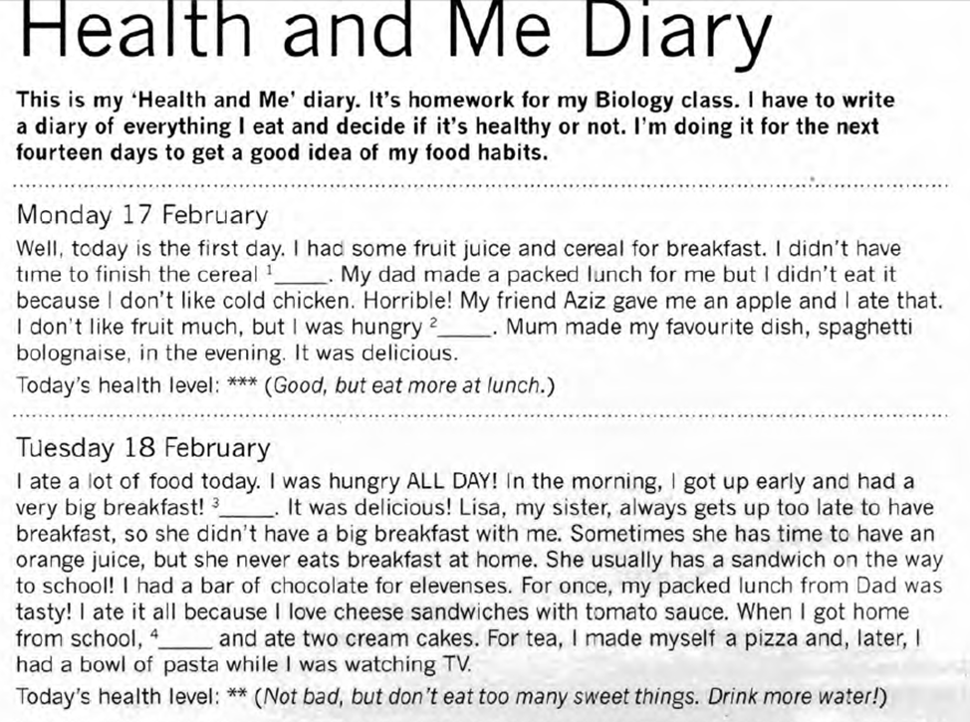

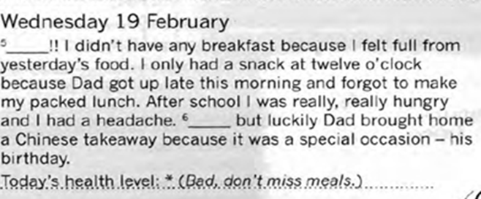

**Read the blog again. Guess if the statements are true or false.**  **Mark ____ / 6**

|  |  |  |  |
| --- | --- | --- | --- |
|  | **Statements** | **T** | **F** |
| 1. | Monday isn’t the first day of the nomework diary. |  |  |
| 2. | Helen didn’t eat all her cereal on Monday. |  |  |
| 3. | Helen didn’t have breakfast on Tuesday. |  |  |
| 4. | Lisa had a sandwich at home with Helen for breakfast. |  |  |
| 5. | Helen had two meals on Tuesday evening. |  |  |
| 6. | The family went out for a Chinese meal on Wednesday to celebrate their dad’s birthday. |  |  |

**Task 5. How can you stay healthy? What advice can you give? Mark ____ / 10**





